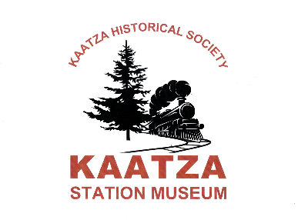

Kaatza Historical Society receives Heritage BC 150 Time Immemorial funding for partnership with Ts’uubaa-asatx First Nation
Lake Cowichan, BC: The Kaatza Historical Society is delighted to announce that they will be receiving a $35,689 grant through Heritage BC’s 150 Time Immemorial grant program to further their recently signed partnership with the Ts’uubaa-asatx First Nation.
The funds will be used to update the Kaatza Station Museum’s internal displays to be more inclusive of the Cowichan Lake region’s rich Indigenous history. This is just one phase of the partnership, which will eventually include indoor and outdoor displays, as well as co-hosted events, and will employ members of the First Nation to direct and advise projects.
Pat Foster, President of the Kaatza Historical Society, says: “We are very pleased that we got this grant, and really pleased that there will be two amazing new displays for First Nations history in our museum. We have a protocol agreement between us and Ts’uubaa-asatx and have really enjoyed working together so far.”
Nuu-Chah-Nulth artist Josh Watts, creative director for all projects stemming from the partnership, says: “As a descendant of the Ts’uubaa-asatx people, I'm proud of the partnership between the Kaatza Historical Society and our people. Through working together in sharing the history of our territory I believe we can strengthen the bond between our nation and the town.”
The development of the internal displays will follow hot on the heels of an outdoor totem pole gathering space, currently being developed by members of both the Historical Society and the First Nation. The totem pole project is being funded by generous financial support from the Island Coastal Economic Trust.
The Kaatza Historical Society wishes to thank Aaron Hamilton, Melanie Livingstone, and Josh Watts of the Ts’uubaa-asatx First Nation, as well as all funders behind the project, for their support of this meaningful and culturally significant project.

Contact:
Kaatza Station Museum and Archives – kaatzamuseum@shaw.ca – (250) 749-6142

